

Profile Drag and Wake Momentum

Deficit Lab Report

Lab Group 07: Himmat Kaul, Brendan Frain, Emre Aslan, Yujie Hao, Suhail Halaby, Nicolas Zhou.

CID: 02376386

5th December 2024

**Contents**

List of Figures 2

List of Tables 2

List of Symbols 2

1. Objectives 3

2. Experimental results 3

2.1. Chord-wise Pressure Distribution 3

2.2. Thickness-wise Pressure Distribution 4

2.3. Wake Momentum Deficit Profile 4

2.4. Integrated Experimental Aerodynamic Coefficients 5

3. Error analysis 5

3.1 Error Propagation 5

3.2 Integration Error 6

4. Discussions 6

4.1. Forms of Drag 6

4.1.1. Pressure Drag 6

4.1.2. Skin Friction Drag 6

5. Numerical results 7

5.1. Solver Setup, Parameters and Tunnel Conditions 7

5.2. Mesh Grid Independence Study 7

5.3. Simulation Results 8

6. Conclusions 8

# List of Figures

Figure 1: Chord-wise Pressure Distribution 3

Figure 2: Thickness-wise Pressure Distribution 4

Figure 3: Integrand Plot 4

Figure 4: Solver Setup 7

Figure 5: Pressure Distribution Base Size Study 7

# List of Tables

Table 1: Experimental Conditions 3

Table 2: Coefficients 5

Table 3: Gaussian Fit Parameters 5

Table 4: Measurement Errors 5

Table 5: Model Parameters 7

Table 6: Aerodynamic Forces From StarCCM+ 8

Table 7: Comparison of Results 8

# List of Symbols

|  |  |
| --- | --- |
| $$v$$ | Tunnel Velocity |
| $$T$$ | Temperature |
| $$ρ_{air}$$ | Air Density |
| $$ρ_{ethanol}$$ | Ethanol Density |
| $$P_{a}$$ | Ambient Pressure |
| $$x$$ | Chordwise Direction |
| $$y$$ | Thickness Direction |
| $$x/c$$ | Non-Dimensional Chord |
| $$y/c$$ | Non-Dimensional Thickness |
| $$y_{w}$$ | Wake profile coordinates |
| $$c$$ | Chord Length |
| $$Re$$ | Reynolds Number |
| $$M$$ | Mach Number |
| $$C_{D}$$ | Drag Coefficient |
| $$C_{D_{p}}$$ | Pressure Drag Coefficient |
| $$C_{D_{f}}$$ | Skin Friction Drag Coefficient |
| $$C_{P}$$ | Pressure Coefficient |
| $$C_{L}$$ | Lift Coefficient |

# 1. Objectives

The primary objective of testing aerofoils in a wind tunnel are to determine the aerodynamic polars of the aerofoils. The most important of which are the lift and drag polars which can be obtained using the simple experimental setup used in the lab, for NACA 0015 at $Re=250,000$.

# 2. Experimental results

Tunnel operating conditions and model geometries:

Table 1: Experimental Conditions

|  |  |  |
| --- | --- | --- |
| **Operating Conditions** | | **Units** |
| $$v$$ | 25.03 | $$\left[m/s\right]$$ |
| $$T$$ | 23.1 | $$\left[°C\right]$$ |
| $$ρ_{air}$$ | 1.19 | $$\left[kgm^{-3}\right]$$ |
| $$ρ_{ethanol}$$ | 789.45 | $$\left[kgm^{-3}\right]$$ |
| $$P_{a}$$ | 104,173 | $$\left[Pa\right]$$ |
| $$c$$ | 15.24 | $$\left[cm\right]$$ |
| $$Re$$ | 249,422 | - |
| $$M$$ | 0.072285 | - |

## 2.1. Chord-wise Pressure Distribution

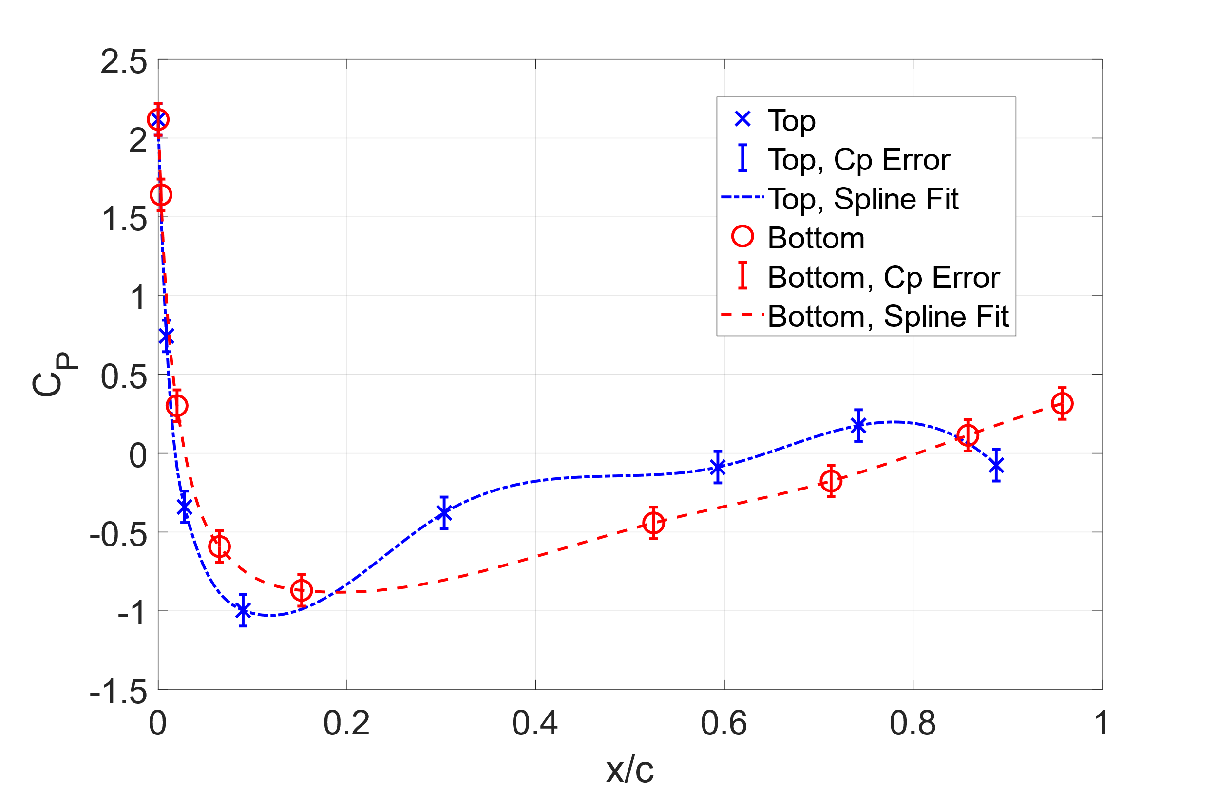

Figure 1: Chord-wise Pressure Distribution

The difference in the top and bottom $C_{P}$ values indicate a higher pressure on the bottom of the aerofoil, indicative of a small amount of lift generation. This Lift is calculated via the Trapezoidal integration of these two curves to calculate the area between the curves. The Interpolation method used to fit the curve was a cubic spline method as it provides good curvature for the points at 0.1 on the chord. However, the spline fit introduces some wavy overfitting on the almost linear region of the plot between [0.2, 1.0].

## 2.2. Thickness-wise Pressure Distribution

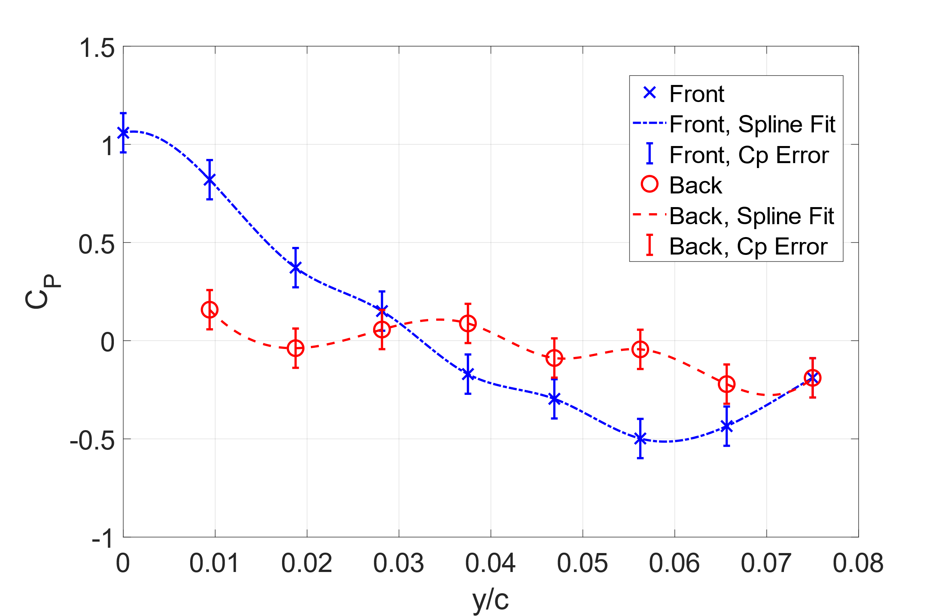

Figure 2: Thickness-wise Pressure Distribution

The difference in area between the lines represents the pressure drag on the aerofoil, which is calculated by trapezoidal integration. The fit used was cubic spline interpolation to allow the representation of the smoothness of the distribution to show. However, the mostly linear regions between [0.01,0.05] are overfitted and are excessively wavy.

## 2.3. Wake Momentum Deficit Profile

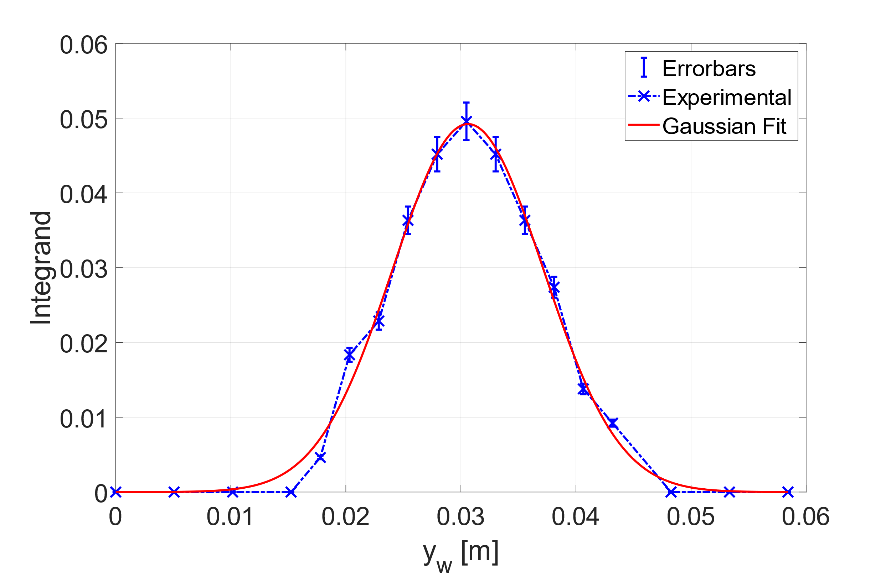

Figure 3: Integrand Plot

The Intergrand Plot Represents the Momentum Deficit in the Wake shown in equation (1) and is used to calculate $C_{D}$. A Gaussian fit was used to fit the distribution of the wake this was done to simplify the area calculations and compare the $C_{D}$ from a trapezoidal integration scheme compared to fitting the analytical equation. The Gaussian fit well approximates the plot peak however fails to replicate the experimental results along the region between [0.01, 0.02]. a line connecting data points is also represented to show the effective area calculated by the Trapezoidal scheme is similar to the Gaussian.

## 2.4. Integrated Experimental Aerodynamic Coefficients

Table 2: Coefficients

|  |  |  |  |  |
| --- | --- | --- | --- | --- |
| **Integration Method** | $$C_{D}$$ | $$C_{D_{p}}$$ | $$C_{D_{f}}$$ | $$C_{L}$$ |
| Trapezoidal | 0.01045 ± 0.0009 | 0.0073 | 0.0032 | -0.10142 |
| Gaussian | 0.01059 ± 0.0010 | 0.0073 | 0.0033 | -0.10142 |

Profile Drag is calculated using the formula:

()

From the experimental data, two methods were used to find the integral. Firstly, using a First Order Gaussian fit, which is commonly used to fit peaks, yields the fit equation:

()

Table 3: Gaussian Fit Parameters

|  |  |
| --- | --- |
| **Parameters** | **95% confidence Bounds** |
| $$a_{1}= 0.04920$$ | (0.04705, 0.05135) |
| $$b_{1}= 0.03062$$ | (0.03029, 0.03095) |
| $$c_{1}= 0.00925$$ | (0.008771, 0.009729) |

The $C_{D}$ is given from the model empirically by:

()

Using the Trapezoidal Integration technique and the existing data points yields the value of

$$C_{D} = 0.01045±0.0009$$

# 3. Error analysis

The accuracy of all measurement instruments is recorded in the table. The error Propagation for the pressure drag is calculated via the error propagation of $U_{C_{P}}$ The total Drag Coefficient is outlined below and the subsequent integral errors are calculated.

## 3.1 Error Propagation

Error propagation table of associated errors for instruments and formulas used

Table 4: Measurement Errors

|  |  |  |  |
| --- | --- | --- | --- |
| **Instrument/Quantity** | **Symbol** | **Measurement error (±)** | **Units** |
| Manometer height scale | $$U_{h }$$ | 1 | $$\left[mm\right]$$ |
| Manometer angle gauge | $$U_{θ}$$ | 0.5 | $$\left[°\right]$$ |
| Wind tunnel Velocity | $$U_{v}$$ | 0.005 | $$\left[m/s\right]$$ |
| Pressure Coefficient | $$U_{C_{P}}$$ | - | $$\left[Pa\right]$$ |

Via error propagation of summing the squares we arrive at the formula below:

()

## 3.2 Integration Error

For the Gaussian fit, upper and lower 95% confidence bounds were given for each parameter value in Table 3. Hence the error in the $C_{D}$ can be given by:

$${U_{C}}_{D}= \frac{1}{2}\left(\frac{2}{c} \left(a_{upper}c_{upper}\sqrt{π}\right)-\frac{2}{c} \left(a_{lower}c_{lower}\sqrt{π}\right)\right) = ±0.0010$$

For the Trapezoidal integration scheme on [${y_{w}}_{a},{y_{w}}_{b}$] with $n$ strips, the error is given by:

()

Assuming a Gaussian fit for simplifications, $max(f^{''}(x)) = \frac{2a_{1}}{{c_{1}}^{2}}$

$${U_{C}}_{D}=\frac{2}{c}\frac{{\left({y_{w}}_{b}-{y_{w}}_{a}\right)}^{3}}{12n^{2}} (\frac{2a_{1}}{{c_{1}}^{2}})=±0.0009$$

# 4. Discussions

## 4.1. Forms of Drag

Multiple forms of Drag occur, however the most dominant in this region of flow are Pressure and Skin Friction Drag.

### 4.1.1. Pressure Drag

The Pressure Drag occurs due to the pressure difference between the front and back of the aerofoil geometry. Caused by the component of the pressure force perpendicular to the surface acting in the chordwise direction. The Pressure Drag Coefficient is calculated by trapezoidal integration of Figure 2 using the below equation (6).

()

Where $C_{P_{F}}$ and $C_{P_{R}}$ are the front and Rear Pressure Distributions respectively.

### 4.1.2. Skin Friction Drag

The Skin Friction Drag occurs due to the wall shear forces parallel to the surface acting on the fluid flow in the boundary layer of the aerofoil. These shear forces arise due to viscous flow around the aerofoil and the no-slip condition on the aerofoil surface. Skin Friction Drag Coefficient is calculated by (7).

()

Where $C_{D}$ is the total drag calculated from the Wake of the Aerofoil.

# 5. Numerical results

## 5.1. Solver Setup, Parameters and Tunnel Conditions

The model was set up using version 2206 of SIEMENS Simcenter STAR-CCM+ from 2022, and part and tunnel geometries were provided. The solver setup used is provided in Figure 4. The parameters and tunnel conditions used are summarised in Table 5.

|  |  |  |  |  |  |  |  |  |  |  |  |  |  |  |  |  |  |  |  |  |  |  |  |  |  |  |  |  |  |  |  |
| --- | --- | --- | --- | --- | --- | --- | --- | --- | --- | --- | --- | --- | --- | --- | --- | --- | --- | --- | --- | --- | --- | --- | --- | --- | --- | --- | --- | --- | --- | --- | --- |
| Table 5: Model Parameters   |  |  |  | | --- | --- | --- | | **Simulation Parameters** | | **Units** | |  | 25.03 |  | |  | 23.1 |  | |  | 1.19 |  | |  | 104,173 |  | |  | 15.24 |  | |  | 249,422 | - | | *Turbulence Intensity* | 0.002 | - | | *k (Turbulent Kinetic Energy)* | 0.003759 | - | | *Turbulent Length Scale* | 0.028956 | - | | Figure 4: Solver Setup |

## 5.2. Mesh Grid Independence Study

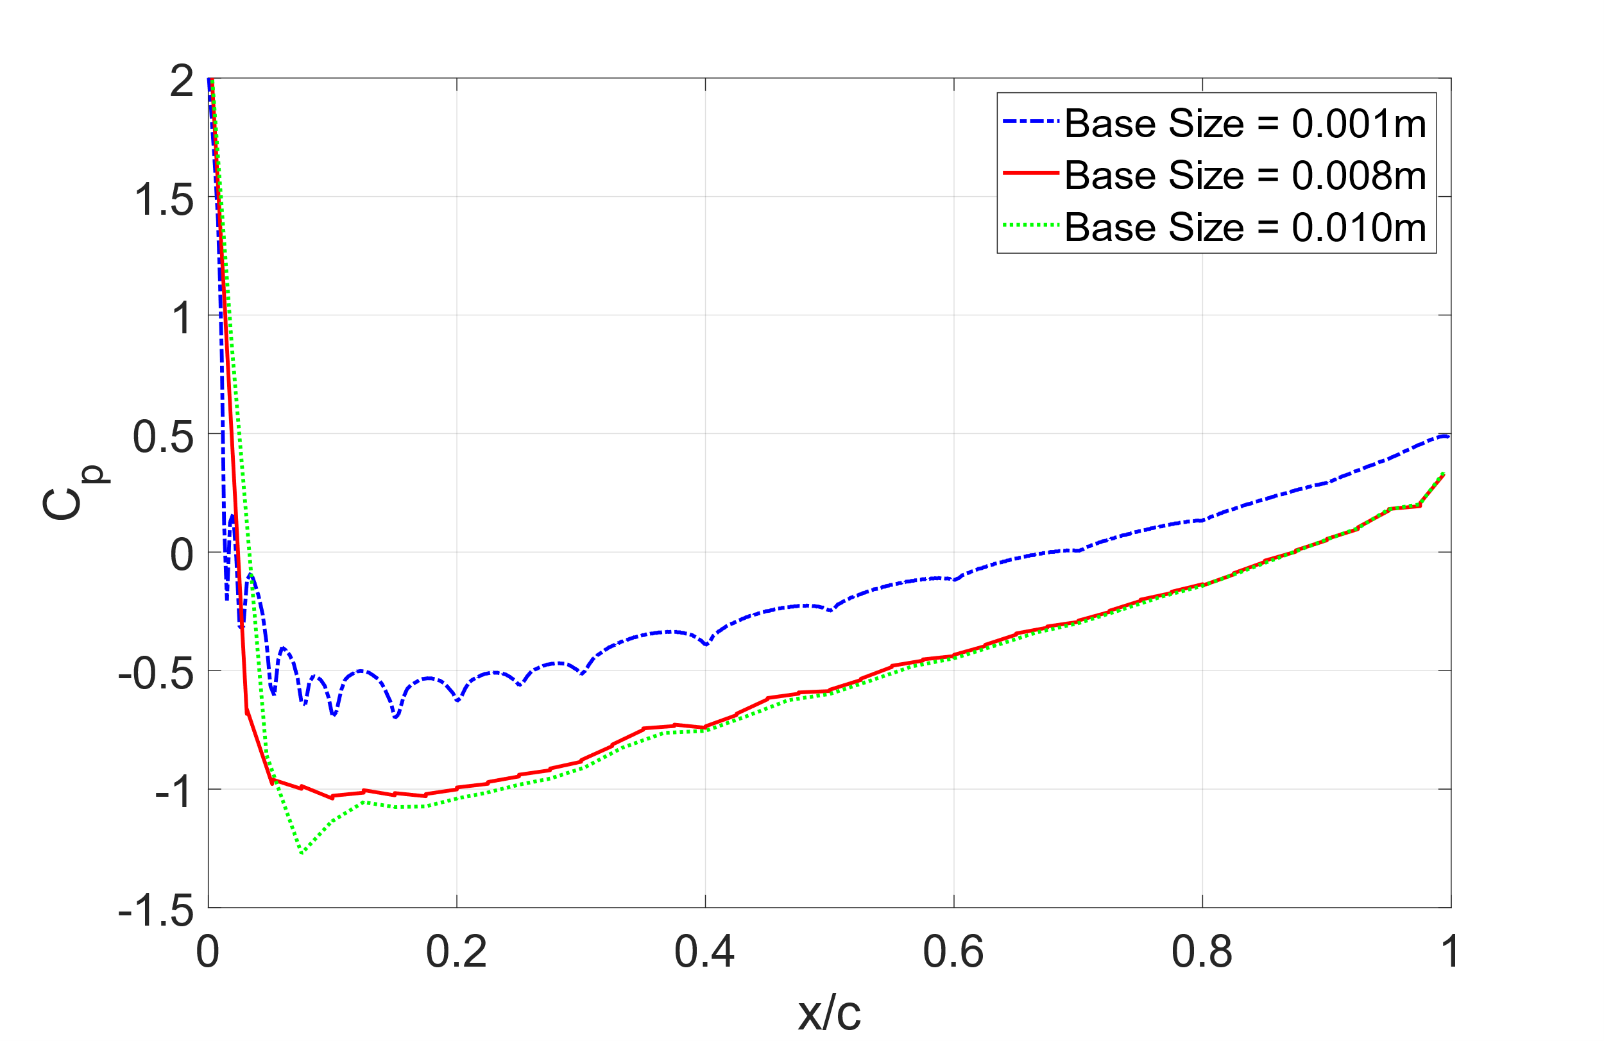

Figure 5: Pressure Distribution Base Size Study

The average pressure distribution along the x-axis from the CFD was calculated by averaging the top and bottom pressure values along the aerofoil surface. The plots show similarities to the top and bottom distribution of the experimental results and are indicative that the mean pressure values fall within the bounds of the curves in Figure 1 for base sizes 0.001m and 0.008m but are outside of the range for base size of 0.010m.

Table 6: Aerodynamic Forces From StarCCM+

|  |  |  |  |  |
| --- | --- | --- | --- | --- |
| **Base Size [m]** | $$C_{L}$$ | $$C_{D}$$ | $$C_{D_{p}}$$ | $$C_{D_{f}}$$ |
| 0.001 | -0.001752059 | 0.045398009 | 0.020156083 | 0.025241926 |
| 0.008 | -0.001752028 | 0.045277466 | 0.020222744 | 0.025054723 |
| 0.010 | -0.001754807 | 0.045297251 | 0.020234467 | 0.025062785 |
| 0.100 | -0.001754432 | 0.050986635 | 0.020246419 | 0.030740216 |
| **Average** | **-0.001752965** | **0.045324242** | **0.020204431** | **0.025119811** |

Note: Base Size = 0.100m is not included in the Average values.

The Mesh Grid Independence Study was conducted with the Base Sizes listed and provided sufficiently close values for a range of Base sizes between 0.010-0.001m, which indicates grid independence for this range. The average was then taken to compare with the experimental values.

## 5.3. Simulation Results

Table 7: Comparison of Results

|  |  |  |  |  |  |
| --- | --- | --- | --- | --- | --- |
| **Method** | | $$C_{D}$$ | $$C_{D_{p}}$$ | $$C_{D_{f}}$$ | $$C_{L}$$ |
| Experimental | Trapezoidal | 0.01045 ± 0.0009 | 0.0073 | 0.0032 | -0.10142 |
| Gaussian | 0.01059 ± 0.0010 | 0.0073 | 0.0033 | -0.10142 |
| CFD | Average | 0.04532 | 0.0202 | 0.0251 | -0.00175 |

The Experimental Data collected varies vastly in comparison to the CFD data in all aspects. The CFD results predict Skin friction Drag to be the dominant drag, which is expected due to the thin aerofoil shape. However, experimental results contradict this hypothesis due to the presence of Higher pressure drag compared to skin friction drag. This is most likely an error in the experimental results which may have been influenced by the 3D-wing effects which become more prominent in the larger wind tunnel.

Overall, the Experimental data predicts an almost 400% increase in total drag for the CFD study compared to the experimental data. There is additionally an order of magnitude difference in the skin friction and pressure drag between the CFD and Experimental results respectively

# 6. Conclusions

**Experimental Improvements**

* Use of a Smaller Wind tunnel to better mitigate 3D Wing effects
* Use of Digital Manometer to increase precision and negate human error
* Use of turning wheel for more precise angle setting
* Resting the Manometer on a level surface to allow for consistent ambient height readings

**Numerical Simulation Improvements**

* Use of a model with movable angle of attack to help better set zero lift AOA in the simulation.
* Use of multiple solvers better suited to Turbulent and Transition flow regains to better approximate the Boundary layer as the RANS (Reynolds Averaged Navier Stokes) Solver may perform worst in the Flow Regime compared to a more complex LES or DNS solver.